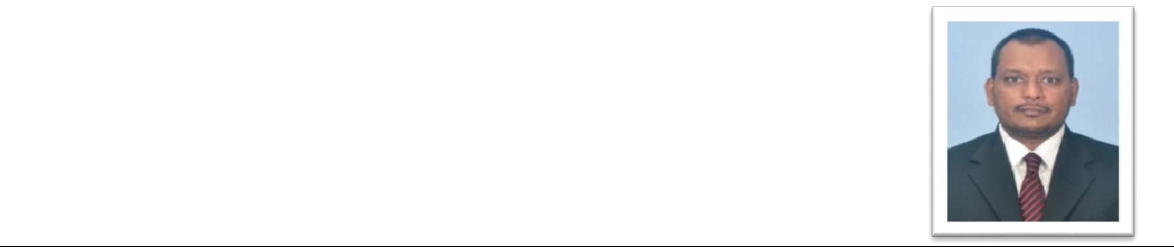
CURRICULUM VITAE

Sameera Wathsala Wickramarathna K.

No.143/1, Aliwalapalla, Walgammulla

Weyangoda, Sri Lanka

Mobile: 0094-7799043400 / 0094-715125747/ 0094-332278159

E-Mail: sameerawickramarathna04@gmail.com

PERSONAL SUMMARY:

A self motivated and dedicated person who takes pride in facing the dynamic business environment with fullest enthusiasm. Have extensive experience in financial markets and performance reporting. Has a good analytical mind and is a very good team player. Willing to go the extra mile in order to perform any job assigned beyond expectation.

WORK EXPERIENCE


- Vishwin Money and Exchange Brokers (Pvt) Ltd, Sri Lanka

Industry Profile

Vishwin Money & Exchange Brokers Ltd is a fully owned subsidiary of Trillion Securities (Pvt) Limited. It is appointed and authorized by the Central Bank of Sri Lanka as a Money brokering firm to act as an intermediary in Call money, Repo, Forex, Treasury Bills, Treasury Bonds, FCBU & dollar deposit transactions.

Job Profile

- Assistant Manager – Dealing (01 April 2015 – Present)

- Union Assurance PLC, Sri Lanka

Industry Profile

Union Assurance is one of Sri Lanka’s largest providers of life and general insurance solutions in the country. Anchored by a team of experienced and dynamic professionals, a strong capital base and reinsurance partnerships with highly rated global reinsurers, Union Assurance offers a wide range of tailor-made insurance products and services that are of international standards.

Job Profile

  - Assistant Manager (01 April 2013 – 31/03/2015)

  - Executive (01 April 2011 – 31/03/2013)

- Insurance Assistant ( 01 Sep 2008 – 31/03/2011)

Duties and Responsibilities

- Involve in developing and implementing the financial policies, systems and procedures for the company.
- Co-ordinate the preparation of financial statements, summaries, and other cost-benefit analyses and financial management reports
- Financial planning and preparing budgets and variance analysis
- Analyzing cost models and carrying out material variance analysis


CV SAMEERA W. WICKRAMARATHNA 1

- Evaluate financial reporting systems, accounting procedures and investment activities and make recommendations for changes to procedures, operating systems, budgets and other financial control functions to senior managers and other department or regional managers
- Notify and report to senior management concerning any trends that are critical to the organization's financial performance.
- Preparation of investment research reports by calculating financial ratios & Analyzing creditworthiness of the companies. From the above I form a recommendation on the attractiveness of the investment and this is used by the Board Investment Committee in deciding on Equity and Fixed income investments.

- Handled the Life Insurance Fund, The General Insurance Fund and the Unit Linked Life Fund at different times in my tenure at UA and have managed the Funds in terms of investing new fund flows, reinvestment of any maturities and interest, sales and disposals, performance management of the funds and liquidity management of the funds.

- In terms of reporting and MIS at Investments Department I have;

  - Prepared Fund performance statements for equity and fixed income investments on a monthly basis.

  - Calculated the re-investment rate of the funds on a monthly basis.

  - Have been in charge of the unit price calculation process of the unit linked funds.

  - Prepared Investment Committee papers on the Fund performance.

- Have carried out all operational aspects of fund management including dealing with custodians, primary dealers, Brokers, banks etc and managed daily and periodic cash flows and developing short term and long term investment strategies for the Funds.

- Prepared a monthly and quarterly newsletter on the Unit Linked fund performance to the sales force and conceptualized and implemented improvements to the above from time to time.

- Was an active member of the team that implemented SAP Treasury module in UA and extensively took part in testing.

- Actively participate in preparing the Annual report of the company. Conceptualized and prepared The Intellectual Capital report in AR 2014.

PROFESSIONAL QUALIFICATIONS:

- Final year of MBA in Finance at University of Colombo, Sri Lanka .

- Completed Chartered Institute of Management Accountants (CIMA) Foundation Level & Managerial Level 11 .

- Followed the Diploma in Business Information Technology (DBIT) Course at The Institute of Bankers .

ACADEMIC QUALIFICATIONS:

- Graduated in Bachelor of Commerce (Special) Degree (B.COM) in Department of Commerce & Financial Management, University of Kelaniya (2009), Sri Lanka.

- Advanced Level in 2004 : G.C.E Advanced Level- 2 A & 1 B passes-Commerce Stream .

- Ordinary Level in 2001: G.C.E Ordinary Level-3 Distinctions including English, Commerce & Music & 5 Credits .
CV SAMEERA W. WICKRAMARATHNA 2

EXTRA-CURRICULAR ACTIVITIES

- Senior Member of University Table Tennis team (2007/2008).

- Editor (Magazine) of The Association of Commerce & Management Education (ACME) of university of Kelaniya, Sri Lanka.
- Senior prefect in School. (2000/2004)
- Have won the 2nd place at the junior National Karate Championship

- Organizer of the School Creativity Club

IT SKILLS

- MS word , Excel and Power point
- SAP Treasury module

Personal Profile

• | Full Name | : Kadinappulige Sameera Wathsala Wickramarathna
• | Date of Birth | : 04th July 1985 (30 years)
• | Sex | : Male
• | Civil Status | : Single
• | Nationality | : Sri Lankan
• | Passport No | : N5239555

REFEREES
 | Dr.Nishantha Busige |  | Mr. Kumudu Jayawardana,
 | Senior Lecture |  | Senior Manager - Investments
 | Department of Management and Organization |  | Union Assurance PLC
 | Studies, |  | No 20, St .Michael’s Road, Colombo 03 ,
 | Faculty of Commerce and Management Studies, |  | Sri Lanka
 | University of Colombo, Sri Lanka |  | Phone : 0094-777736120
 | Mobile: 0094-7181188582 |  | E mail : kumuduj@ualink.lk

I hereby certify that the above details are true and accurate to the best of my knowledge.

………………………………………..
K.S.W WICKRAMARATHNA 10/10/2015

CV SAMEERA W. WICKRAMARATHNA 3

